Lesson Plan #5 (Outdoor Plan): How do simple machines make our work easier?

- LEARNING OBJECTIVES
- Students will be able to demonstrate their knowledge about simple machines by identifying different types of simple machines on the playground.
- Students will be able to say how each of the simple machines makes their work easier, given an example of that simple machine.

- STANDARDS
National Standards:
  - Science as Inquiry Standards: Abilities necessary to do scientific inquiry; Understanding about scientific inquiry.
  - Physical Science Standard: Position and motion of objects.
Indiana State Standards:
  - Nature of Science Standards:
    - Use a scientific notebook to record predictions, questions and observations about data with pictures, numbers or in words.
    - Conduct investigations that may happen over time as a class, in small groups, or independently.
    - Make predictions based on observations.
    - Discuss observations with peers and be able to support your conclusion with evidence.
  - The Design Process Standards:
    - Identify a need or problem to be solved.
    - Document the design throughout the entire design process.
    - Brainstorm potential solutions.
    - Select a solution to the need or problem.
    - Select the materials to develop a solution.
    - Create the solution.
    - Evaluate and test how well the solution meets the goal.
    - Communicate the solution with drawings or prototypes.
    - Communicate how to improve the solution.
  - Content Standards:
    - Physical Science 2.1.6 Observe, demonstrate, sketch and compare how applied force (i.e., push or pull) changes the motion of objects.
    - Physical Science 2.1.7 Investigate the motion of objects when they are acted upon at a distance by forces like gravity and magnetism.

- MATERIALS
  - Pencils (1 for each student)
  - Clipboards (1 for each student)
  - Playground Equipment Worksheet (attached at end of lesson)
  - Summative Assessment Worksheet
  - Playground Equipment (We will be walking to a local public school playground)
  - Parent Volunteers-to help walk to and from the playground
- TEACHER CONTENT KNOWLEDGE
- Teachers should know that work is the force multiplied by the distance the object is moved. (If there is no movement, there is no work.)
- Teachers should know that gravity (the downward force caused by the large size of the earth) and friction (the resistance that happens when two surfaces come up against each other) make work more difficult, and simple machines like pulleys, wheels/axles, levers, and inclined planes counteract the forces of gravity and friction to make work easier.

- REFERENCES & HANDOUTS (attached at end of document)
- Playground Equipment Worksheet
- Summative Assessment Worksheet
- Book: “How Do You Lift A Lion?” –Robert E. Wells

- DESCRIPTION OF YOUR LESSON
- Before we begin this week’s lesson, we will finish the “jumping jack” toys and talk about how they use levers to work. Students who finish early will be able to listen to the story “How Do You Lift a Lion?” by Robert E. Wells, which is about how different simple machines can help make work easier.
ENGAGE
As a class, we will talk about how levers make work easier, and talk about simple machines in general making work easier. Students will come up with some real-life examples of different simple machines, hopefully at least one for each week we’ve been in Saturday Science (an inclined plane, a wheel/axle, a pulley, and a lever).
EXPLORE
Students will be given a worksheet that has all of the different examples of simple machines that are on the playground. They will label each one and if it is an inclined plane, a wheel/axle, a pulley, or a lever. They will be given time to explore how the different pieces of playground equipment work, as well as a little time to play after they have completed their worksheet.
EXPLAIN
Students will discuss how each of the different pieces of playground equipment makes work easier.
ELABORATION
Students will complete a summative assessment about simple machines, drawing an example of each type, and completing an explanation for why they make their work easier. This will help us as teachers see the progress students have made over the five lessons.

- EMBEDDED FORMATIVE ASSESSMENT (also part of the 5th “E”)

  - Engage Phase: Students will be asked for several examples of the different types of simple machines. They will answer with examples they have learned in the past 4 lessons or ones they have come up with on their own after the first 4 lessons.
  - Explore Phase: Students will be asked to identify which pieces of playground equipment are different types of simple machines on a worksheet. Teachers will use this to see if there are any concepts they need to explain about the different pieces of playground equipment.
  - Explain Phase: Students will be able to use their own words to explain how each of the pieces of playground equipment makes their work easier. Teachers will use this to see if they understood what made each of the different pieces a simple machine.
  - Elaborate Phase (this is actually summative assessment): Students will give examples of other simple machines they have seen or used and will be able to demonstrate their knowledge of some of the vocabulary we have used in the class.

- GEARING UP/GEARING DOWN
- Gearing up – If students have finished their worksheets during the explore phase early, they can try to find other examples of simple machines and see if they can identify them as well. If they are doing very well before the summative assessment, they can use their own words to fill out how each of the types of simple machines make work easier.
- Gearing down – If some students are struggling with the elaborate phase (this is where we foresee the most problems), they could pick their favorite 2 types of simple machines and draw and write about both of them instead of all four types.

Playground Equipment Worksheet Name_________________________________

Label each piece of the playground as a type of simple machine.
L=Lever, P=Pulley, W=Wheel and Axle, I=Inclined Plane

Playground Equipment: | Simple Machine Type:
Swings
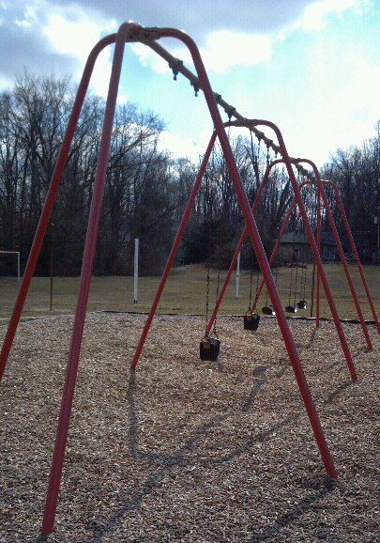
Stairs:
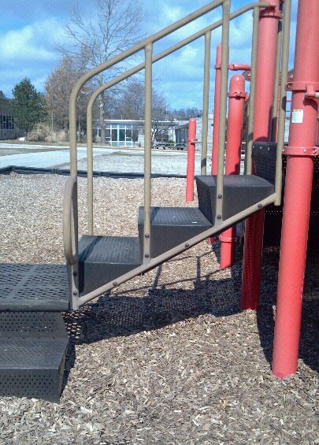
Rings:
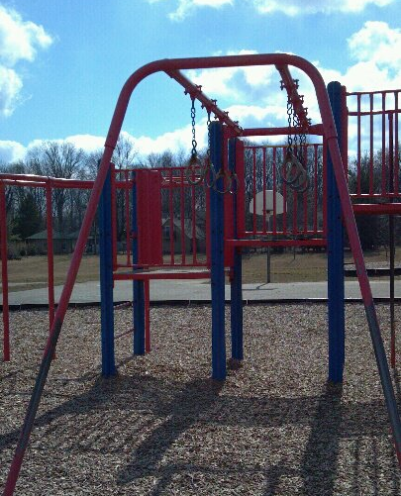
“Rock Climbing” Wall:
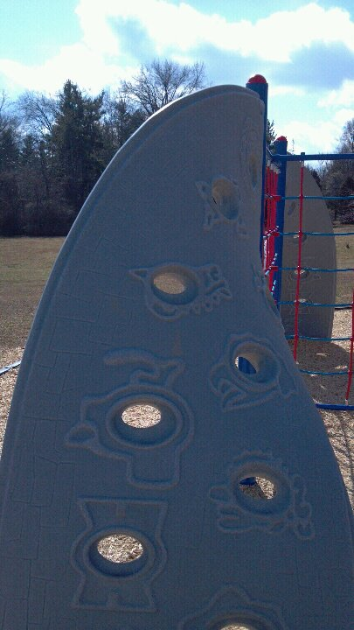
Slides:
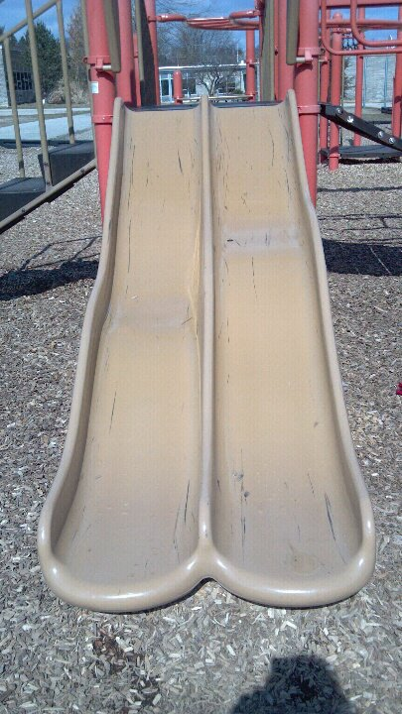
Gears:
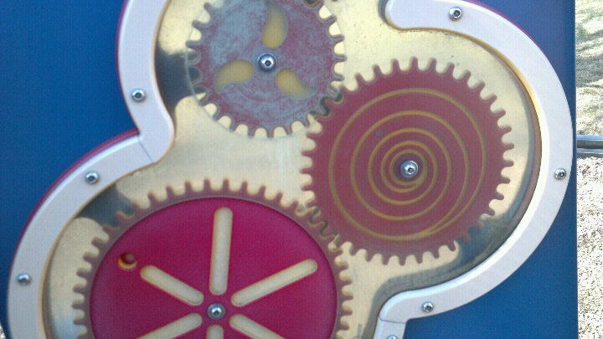
Steering Wheels:
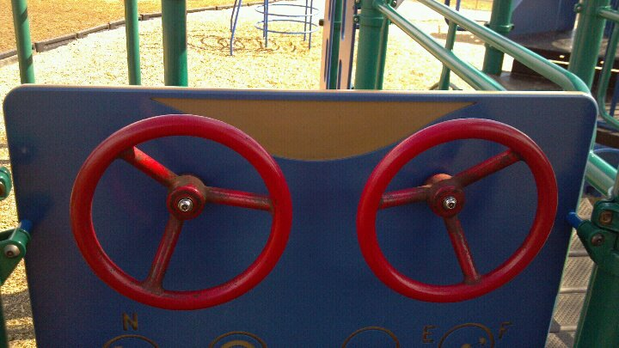
Slider:
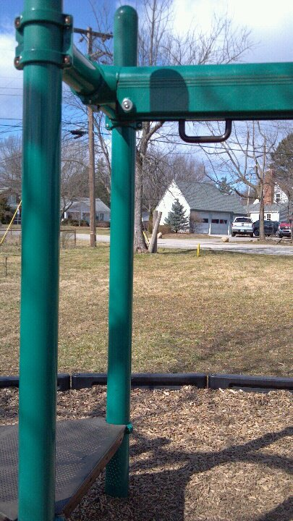

Name_______________________________________
How do simple machines make our work easier?
Draw a picture of each simple machine, and write how it makes our work easier with phrases from the word bank.
Word Bank
Even though you are pulling the string a greater distance, you use less force at one time, making the work easier. | They counteract friction by using gravity. | They counteract the friction of the surface on which they roll. | They let us use less effort to move a larger load with the use of the fulcrum.

Inclined planes make work easier because  ____________________________________________  ____________________________________________  ___________________________________________. | Wheels and axles make work easier because  ____________________________________________  ____________________________________________  ___________________________________________.
Pulleys make work easier because  ____________________________________________  ____________________________________________  ___________________________________________. | Levers make work easier because  ____________________________________________  ____________________________________________  ___________________________________________.
Lesson Plan #5 (Indoor Plan): How do simple machines make our work easier?

- LEARNING OBJECTIVES
- Students will be able to demonstrate their knowledge about simple machines by identifying different types of simple machines on the playground.
- Students will be able to say how each of the simple machines makes their work easier, given an example of that simple machine.

- STANDARDS
National Standards:
  - Science as Inquiry Standards: Abilities necessary to do scientific inquiry; Understanding about scientific inquiry.
  - Physical Science Standard: Position and motion of objects.
Indiana State Standards:
  - Nature of Science Standards:
    - Use a scientific notebook to record predictions, questions and observations about data with pictures, numbers or in words.
    - Conduct investigations that may happen over time as a class, in small groups, or independently.
    - Make predictions based on observations.
    - Discuss observations with peers and be able to support your conclusion with evidence.
  - The Design Process Standards:
    - Identify a need or problem to be solved.
    - Document the design throughout the entire design process.
    - Brainstorm potential solutions.
    - Select a solution to the need or problem.
    - Select the materials to develop a solution.
    - Create the solution.
    - Evaluate and test how well the solution meets the goal.
    - Communicate the solution with drawings or prototypes.
    - Communicate how to improve the solution.
  - Content Standards:
    - Physical Science 2.1.6 Observe, demonstrate, sketch and compare how applied force (i.e., push or pull) changes the motion of objects.
    - Physical Science 2.1.7 Investigate the motion of objects when they are acted upon at a distance by forces like gravity and magnetism.
- MATERIALS
  - 6 Pulleys
  - 3 Wood boards
  - 3 Fulcrums
  - 3 Wood block cars
  - 3 White boards
  - 6 Textbooks
  - 24 Pencils
  - 24 Worksheets
  - 12 Rulers/Stopwatches
  - String
  - Heavy blocks to lift
  - 12 Pairs Scissors
  - 3 Containers for blocks

- TEACHER CONTENT KNOWLEDGE
- Teachers should know that work is the force multiplied by the distance the object is moved. (If there is no movement, there is no work.)
- Teachers should know that gravity (the downward force caused by the large size of the earth) and friction (the resistance that happens when two surfaces come up against each other) make work more difficult, and simple machines like pulleys, wheels/axles, levers, and inclined planes counteract the forces of gravity and friction to make work easier.

- REFERENCES & HANDOUTS
- Handouts attached at end of document.
- Book: “How Do You Lift A Lion?” –Robert E. Wells

- DESCRIPTION OF YOUR LESSON
ENGAGE
We will review what we ended with last week. We will finish our lever man activity and discuss where the fulcrum, lever, and effort is. Our discussion will mainly focus on those three parts of the lever man and finding their location. If students finish with their lever man early, we will have a worksheet for them that has several pictures of simple machines and they will label which machine the picture represents.
Embedded Assessment: We will discuss the lever man and the various parts of him.
EXPLORE
Our first station will be with the lion. We will lift him with a lever. This will be similar to last week when we give the students three scenarios and they have to choose which lever lifts the lion the easiest.

The next activity is a car and inclined plane test. The students will use the block cars and make the inclined planes using the whiteboards and textbooks. The students will then create their own fair-test for the experiment. The students will be given the materials and the students will work on the rest.

The third activity will be a challenge activity in which the students try to design a double pulley. They will have one of the teachers help with the station because this activity is challenging to K-2 students. They will be given the materials and try to build a two-pulley system in which one pulley is fixed and the other is movable.

After finishing each station, the students will return to their seats and have the book How to Lift a Lion read to them and tie that in with the activities they just completed.
Assessment: We will have a worksheet where the students label which lever lifts the lion the easiest or the hardest?

Assessment: The students will have to think of how to test the wheel and axle and the inclined plane in a fair test. This will test their inquiry and process skills as well as what they learned in the previous lesson.

Assessment: The students will draw a picture of their pulley system. They will have to replicate their system with a drawing or sketch.
EXPLAIN
The students will discuss how the work in each station was made easier by the simple machines. We will discuss each station separately focusing on gravity and friction with the inclined plane, distance and force with the pulley, and load and effort with the lever.
ELABORATION
The elaboration piece is when the students will demonstrate their understanding of simple machines.
Assessment: We will have the students draw a picture of each of the four simple machines we discussed in Saturday Science and the students will write a short statement about each machine.

GEARING UP/GEARING DOWN
- Gearing up – If the students are really understanding the materials, we can incorporate an activity in which all of the simple machines need to be used. This can be something where the students test out in pairs which machine works best for certain situations (lifting; moving righ-to-left; etc.) and then report to the class what they find.
- Gearing down – If the students are having difficulties, we will include more instruction, modeling, and support for the activities.

Circle the lever that is the easiest to lift the lion.

Here are some examples of simple machines. Can you label all of them?
L=Lever, P=Pulley, I=Inclined Plane, W=Wheel and Axle
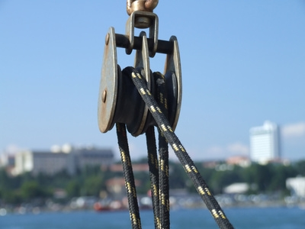
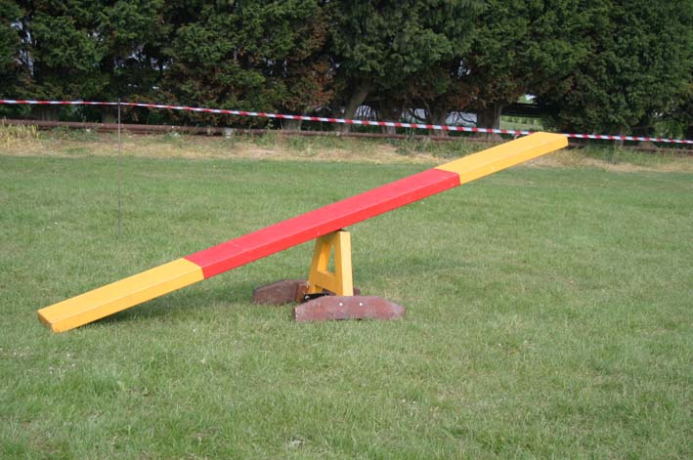
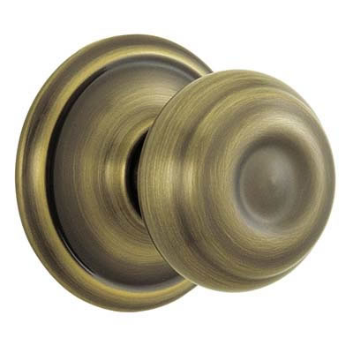
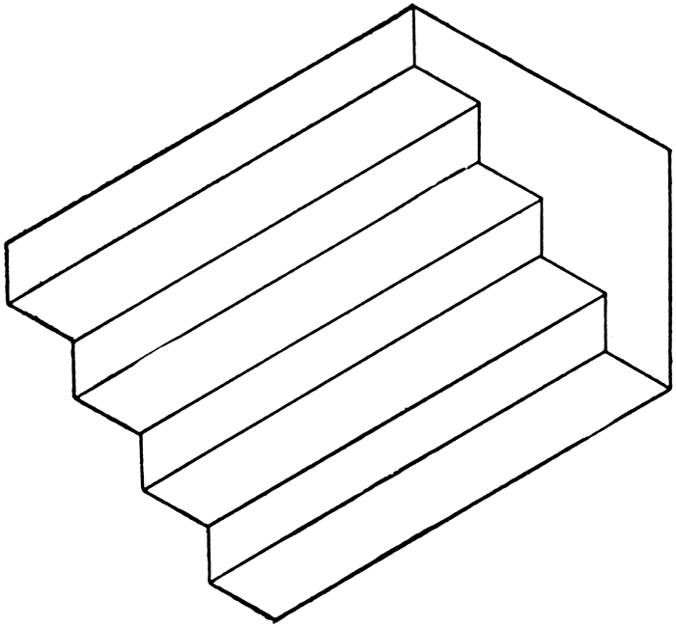

Name:____________________

Inclined Plane/Wheel and Axle Recording Sheet
Time (seconds)
Height of Inclined Plane (centimeters)

